**Describe the main idea**

The game is a tower defence, like Plants VS Zombies or Bloons TD except the enemies are not placed in a set path. Instead, you are placed in a large arena with a tower to defend (toilet paper castle) in the middle of the playing field. Enemies can come from any direction. Most will try to come and destroy your fortress, so you must defend it by placing defensive elements like turrets and shooters around your playing field to prevent them. Other times, there will come enemies that you need to defend as they make your way to your castle. The goal is to make it up to a certain high level of the raid, from which the game is won.

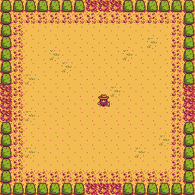

**Its key technical elements (mechanics, code features, etc)**

* HP Bar
* Points (for each enemy destroyed)
* Weapon upgrades for points
* Defences (sentries, perks, upgraded thru points)

**How your design is informed by the technical skills you’ve been taught**

Each enemy will have its own class and will be spawned for each element. The player class will be able to die and respawn. Health functions as a function for the player class, tallied globally.

**How you plan to go beyond what was taught in class**

The player will move freely in a grid, instead of going step by step.

**How you will research or implement elements not covered in class**

* Figure out a Lives system
* Figure out a Health system
* Making a player move freely throughout the grid
* Upgrades and weapon upgrades

We will use the internet to look for code examples for the things we want to to do as well as the P5JS reference for code snippets.

**How your aesthetic, design and technical choices have informed one another.**

The aesthetic will be papercraft as inspired by the artists drawing style. The design will complement this as things will be based around papercraft (ex. paperclip barricades). Our technical choices will mimic the style of papercraft, like having paper-like sound like rustling of paper and cardboard footsteps in order to mimic the aesthetic, instead of using basic shooter sounds.

Extra ideas to put in the game:

* Loot crates
* Weapon upgrades, power ups.
* Barricades